CST 250

Project 3 Report

Team Members:

*John Abbott*

*Chris Ijams*

*David McDonald*

November 1, 2015

**Introduction**

This is an implementation of a simple calculator that uses the UART for both input and output. It is capable of handling addition, subtraction and multiplication of both positive and negative numbers. It uses multiple checks for invalid characters, syntax and input and output overflow conditions and outputs appropriate error messages if any of these are encountered.

**Project Approach**

Our approach changed over the life of the project. We initially planned to write the entire project as a group. In the beginning, we met in person every other day or so to create a flow chart and discuss program logic. It was clear early on that David’s command of PLP was far superior to the others and although we considered using Chris Mar’s project 2 solution as a basis for this project, we eventually agreed that David’s project two would be a better choice. Chris Ijams tried to help with solving coding issues but ultimately made few if any contributions that ended up in the final code. John contributed code such as the calculation functions and the stack initialization section, as well as making some adjustments such as using the $a2 register for temporary values instead of multiple dedicated registers as had been true of the original code as well as numerous tweaks to ensure or improve various functions. David and John made all the design decisions. David made the majority of coding contributions and John handled the majority of the administrative tasks including creating/maintaining the BitBucket repository and managing communications with team members and faculty. Chris Ijams was enthusiastic but wasn’t able to contribute very much to the design or implementation. This division of responsibilities was not by design and shows an area for improvement for project leadership. It is clear that part of the design process must include a plan for the intelligent division of labor and responsibilities.

**Program Description**

The first part of the main initializes the inputs and the UART. The keep track of operators, we use a series of flags and an operator counter, as well as a flag for negative signs. We use $v1 and $v0 to store values and $v1 also stores a running total.

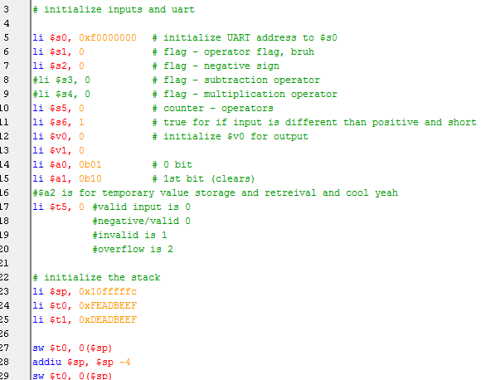

The next function reads values from the UART. It loops until input is received. If it receives the ‘=’ sign, it branches to the write function. If it receives a ‘-‘, ‘+’, or ‘*’, it branches to the **calculate** function:

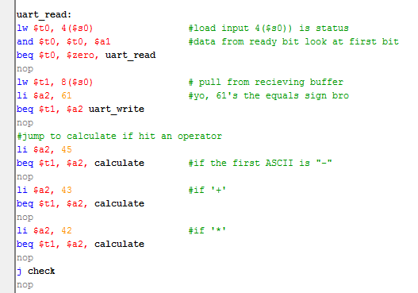

If it encounters anything else, it branches to the **check** function. Here it checks for ‘-‘, ‘+’ and ‘*’ and branches to **subtraction**, **addition** and **multiplication** functions in response. It then checks for characters above and below the range of the numerals in ASCII and branches to a function for handling **invalid** characters if any are encountered.

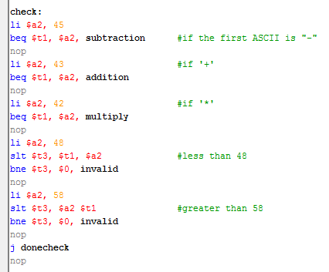

It then continues to the **donecheck** function where numerical values are loaded into the $v0 register where previous values are shifted left and new values are added. It checks for input overflow and branches to that function if found. It otherwise returns to the **uart_read** function.

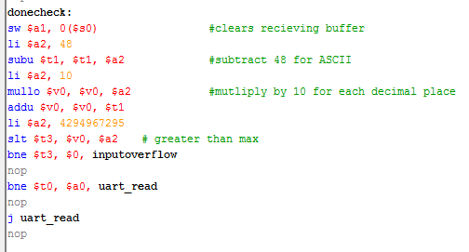

The **subtraction** function is called in the **check** function when a ‘-‘ is received. It checks to see if the “negative flag” is set to 0, if so, it branches to the **negative** function where it checks the “multiply flag” and keeps the value if that flag is flipped. If the “operator flag” is zero, it branches to the **setminus** function where the operator is set to ‘-‘. If the “operator flag” is set to 42, it branches to the **multiply** function.

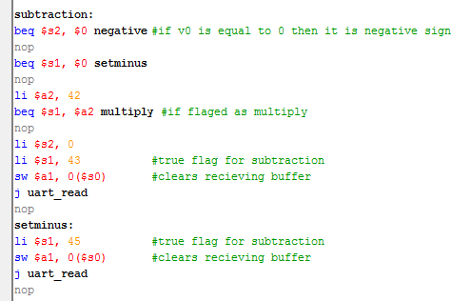

The **addition** and **multiply** functions are similar. They set the “operator flag” to either 43 or 42, clear the receiving buffer and return to the **uart_read** function.

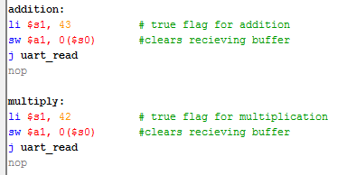

The **twos_compliment** function converts the value in $v0 by flipping the bits using a nor, and adding 1. It then jumps to the **postnegative** function which branches to the appropriate calculation depending on which operator flag is flipped.

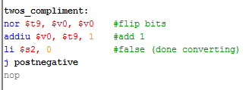

The **invalid**, **invalidexpression**, **inputoverflow** and **outputoverflow** functions all set the $t5 flag. This value is later passed to the uart asm file to trigger the output of the appropriate error message.

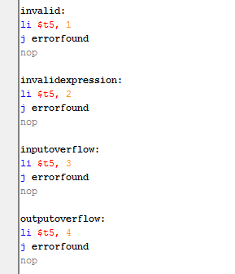

The **calculate** function branches to the **check** function if $v0 hasn’t received a value yet. If the “negative flag” is tripped, it branches to **twos_compliment**.

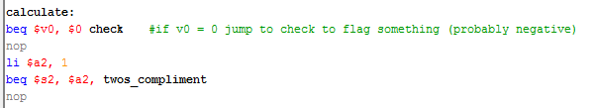

The **movenumber** function moves a value from $v0 to $v1 if $v1 is empty.

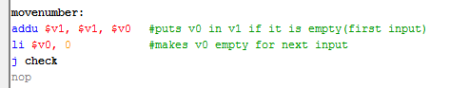

The calculators functions are fairly straight forward. Each one does as its title implies such as performing subtraction, additions or multiplication.

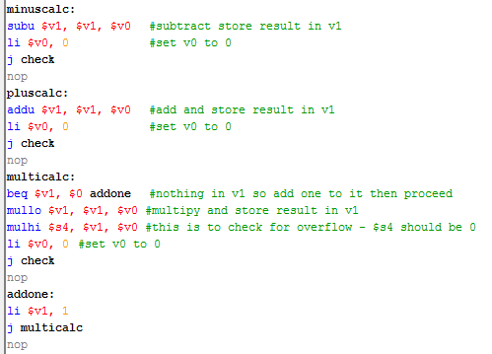

The “final” calculators are copies of the other calculators except that they include a call to finalwrite which sends the data to the uart asm to be written to the uart.

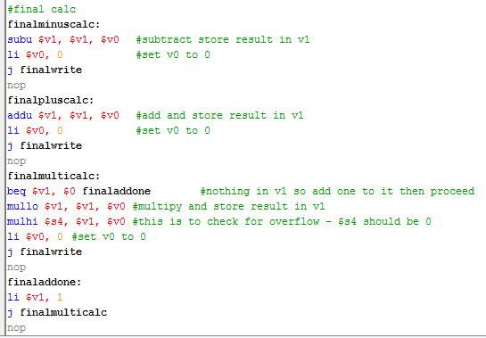

Output functions are handled by the uart asm.

**Lessons Learned**

One of the main things we learned was that discussion of a problem with peers and teaching each other are surprisingly effective at solidifying one’s own knowledge. We also quickly discovered that problems with seemingly simple solutions can be very difficult to implement in code and may require multiple iterations of design and implementation before they work as expected.

Face to face meetings would have been much better spent using some remote communication device if it had the ability to share the computer screen. Next time we will do better research in this area. We could have used a much better way to flow chart the design as well and ended up working from photographs of flow charts written on a whiteboard.

I would also have made a much quicker assessment of each team member’s level of knowledge, abilities and motivations so that each person’s strengths could be better capitalized on. Because this wasn’t done well, a lot of time and resources were wasted.

**Conclusion**

This project was complicated and difficult. There were a lot of issues ended up in one of us finding a solution by accident or having to constantly ask for help from faculty. The reference material we needed to solve problems was not available or was very hard to find.

This project appears to really have been about how to approach a seemingly insurmountable problem. The most important takeaway from this is that the first stages of a project like this should be intensive design work that involves breaking down the problem into as small and as manageable pieces as possible so that each piece and be assigned to an owner and conquered without feeling the weight of the whole task.